

**Exercise Submission**

**Group Members**

Abdullah Ahmed (107)

Eman Murtaza (118)

Laiba Asif (126)

# **Use Cases**

In a use case diagram, we represent interactions between actors (users) and the system (Online Bookstore Management System). Here are some key use cases:

## Browse Books:

|  |  |
| --- | --- |
| **Use Case Id** | UC-01 |
| **Use Case Name** | Browsing Books Use Case |
| **Actors** | Customer |
| **Pre-Condition** | The Online Bookstore Management System is accessible and running. |
| **Description** | Users, both registered customers and guests, can browse the collection of available books in the online bookstore. They can view information such as book titles, authors, genres, and book covers. |
| **Post Condition** | The user is able to view the available books and their details. |

## Search Books:

|  |  |
| --- | --- |
| **Use Case Id** | UC-02 |
| **Use Case Name** | Searching Books Use Case |
| **Actors** | Customer |
| **Pre-Condition** | The Online Bookstore Management System is accessible and running. |
| **Description** | Users can search for specific books based on criteria such as title, author, or genre. The system will provide search results matching the user's input and display them for the user to browse. |
| **Post Condition** | The user is presented with search results matching the specified criteria. |

## Place Order:

|  |  |
| --- | --- |
| **Use Case Id** | UC-03 |
| **Use Case Name** | Placing Order Use Case |
| **Actors** | Customer |
| **Pre-Condition** | The customer is logged into the Online Bookstore Management System and has added books to the shopping cart. |
| **Description** | Customers can select books, add them to the shopping cart, and proceed to place an order. They can review the selected items, provide shipping details, and choose a payment method to complete the purchase. |
| **Post Condition** | The customer's order is successfully placed, and the books are reserved for the customer. |

## Manage Account:

|  |  |
| --- | --- |
| **Use Case Id** | UC-04 |
| **Use Case Name** | Managing Account Use Case |
| **Actors** | Customer |
| **Pre-Condition** | The customer is logged into the Online Bookstore Management System. |
| **Description** | Customers can manage their account information within the online bookstore. They can view and edit their profile details such as name, email address, and shipping address. Additionally, customers can access their order history, track shipments, and manage any preferences or settings associated with their account. |
| **Post Condition** | The customer's account information is updated as per the modifications made by the customer. |

## Admin Functions:

|  |  |
| --- | --- |
| **Use Case Id** | UC-05 |
| **Use Case Name** | Admin Functions Use Case |
| **Actors** | Admin |
| **Pre-Condition** | The admin user is logged into the Online Bookstore Management System. |
| **Description** | Admin users have additional privileges and can perform various administrative tasks within the Online Bookstore Management System. These tasks include managing books (adding, editing, or removing book information), managing user accounts (creating, modifying, or deactivating user accounts), and configuring system settings. |
| **Post Condition** | The requested administrative task, such as adding a book or modifying a user account, is successfully performed. |

## Authenticate User:

|  |  |
| --- | --- |
| **Use Case Id** | UC-06 |
| **Use Case Name** | Authenticating User Use Case |
| **Actors** | System |
| **Pre-Condition** | The user attempts to log into the Online Bookstore Management System. |
| **Description** | The system is responsible for authenticating users to ensure authorized access to the Online Bookstore Management System. It verifies user credentials, such as username and password, to grant appropriate access rights and permissions. |
| **Post Condition** | The user is either granted access to the system or denied access based on the provided credentials. |

## Handle Payment:

|  |  |
| --- | --- |
| **Use Case Id** | UC-07 |
| **Use Case Name** | Handling Payment Use Case |
| **Actors** | System, Payment Gateway |
| **Pre-Condition** | The customer has selected a payment method and initiated the checkout process. |
| **Description** | When a customer places an order, the system interacts with a payment gateway to handle the payment process securely. The system sends the order details and the chosen payment method to the payment gateway, which processes the payment and provides a response to the system indicating the success or failure of the transaction. |
| **Post Condition** | The payment is successfully processed, and the customer receives confirmation of the transaction. |

# Use Case Diagram

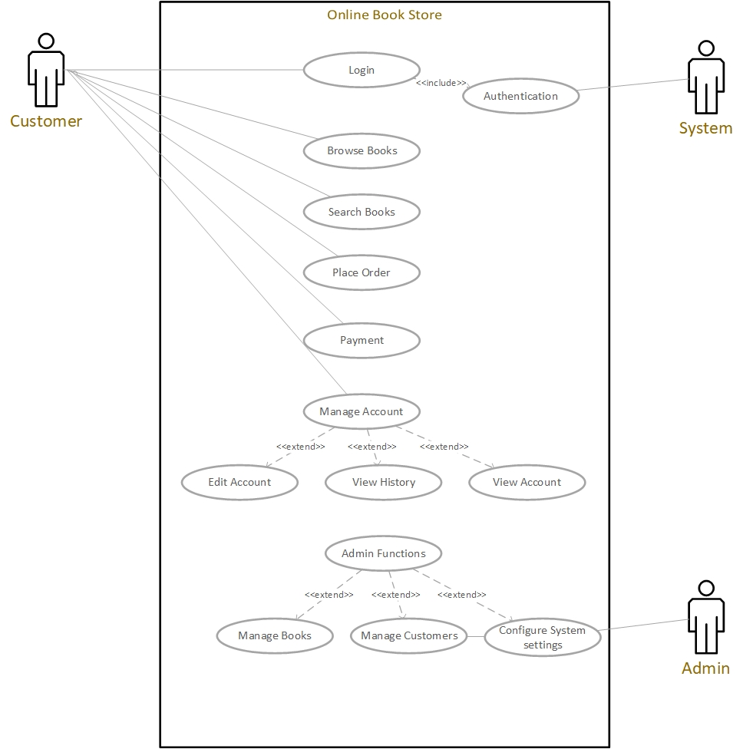

# **Class Diagram**

The class diagram consists of classes such as OnlineBookstore, User, Cart, Book, Admin, and Payment. These classes represent the entities and functionalities of the Online Bookstore Management System, including browsing books, searching books, placing orders, managing accounts, and handling payments. The diagram demonstrates the relationships and interactions between these classes in a simplified manner.

